Milestone 2

http://gfitness.website

1- Create a Meta Title tag for each page on the site.

A title tag is an HTML element that specifies the title of a web page. Title tags are displayed on search engine results pages (SERPs) as the clickable headline for a given result, and are important for usability, SEO, and social sharing. The title tag of a web page is meant to be an accurate and concise description of a page's content.

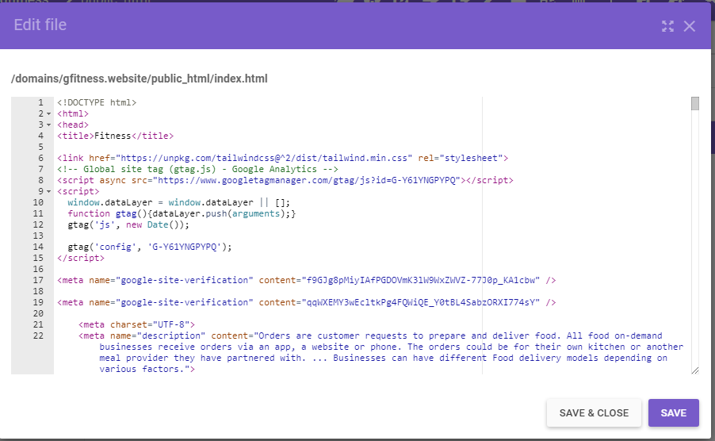

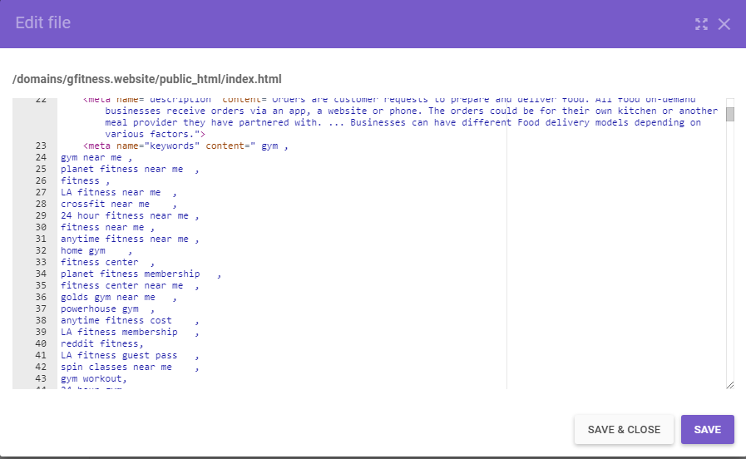

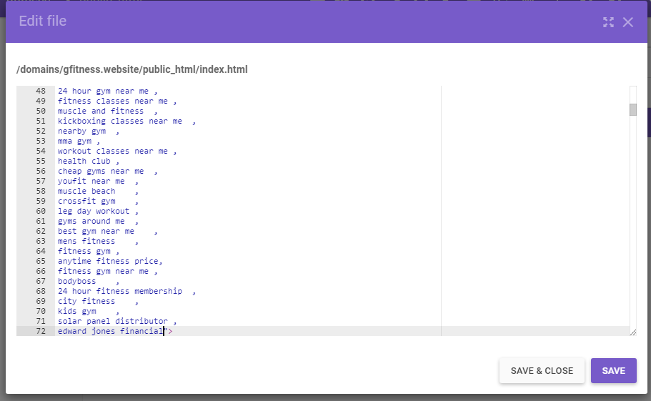

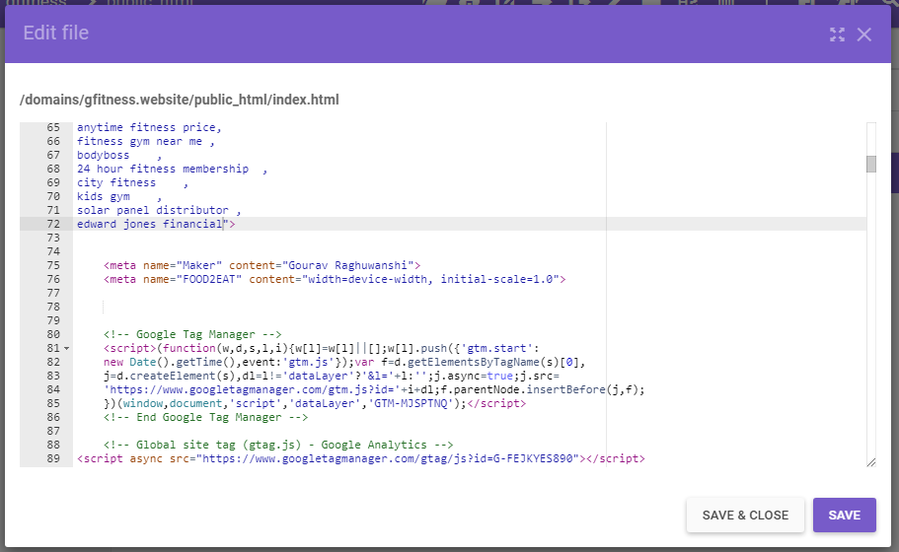

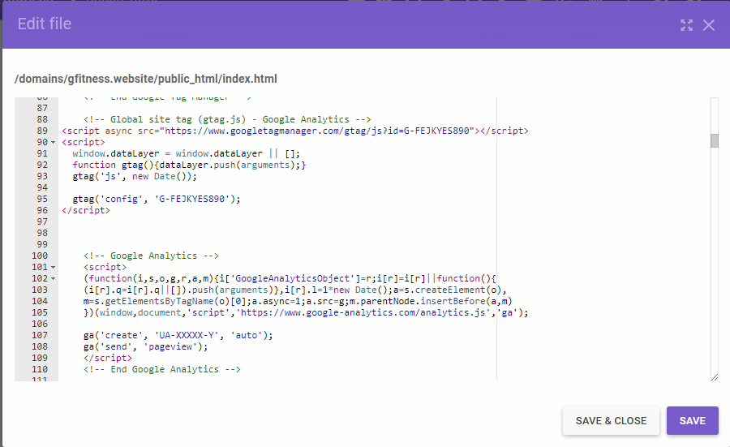

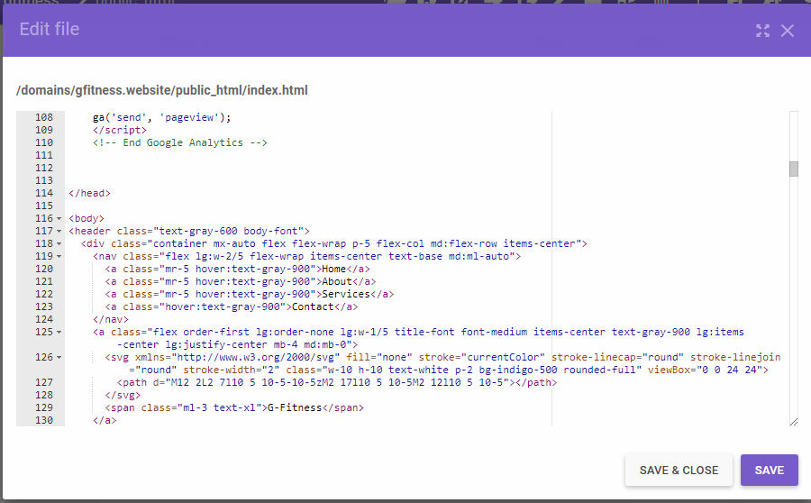

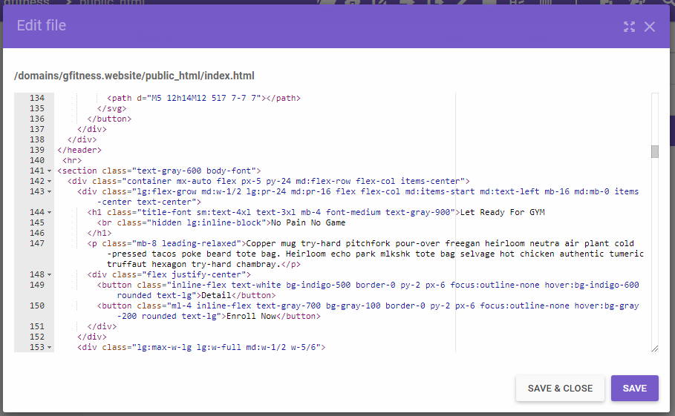

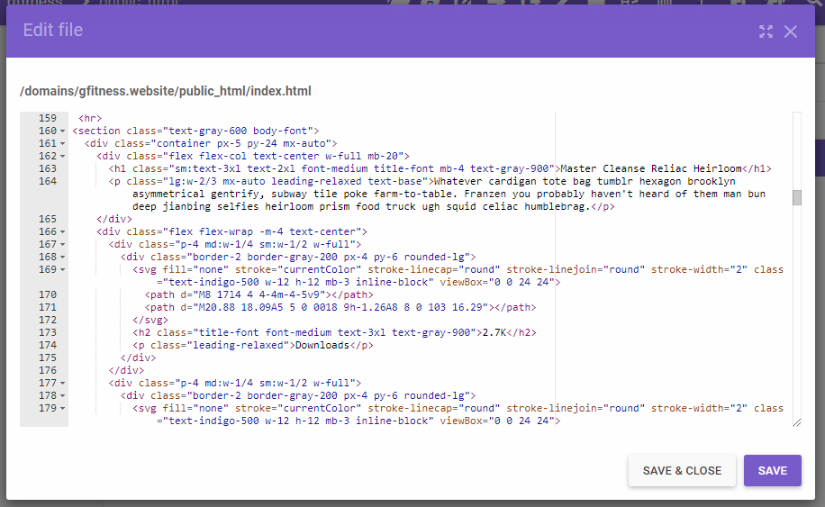

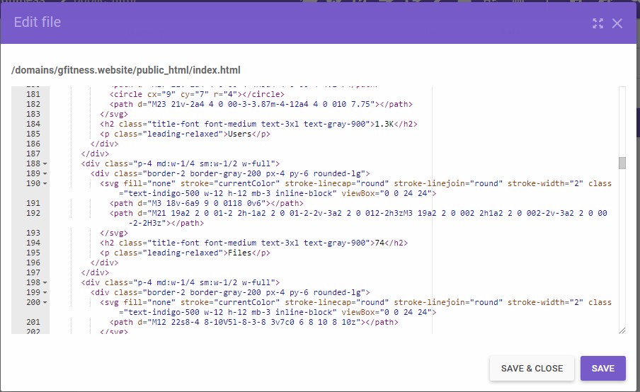

2-Create a Meta Descriptions tag for each page on the site.

The meta description is an HTML attribute that provides a brief summary of a web page. Search engines such as Google often display the meta description in search results, which can influence click-through rates.

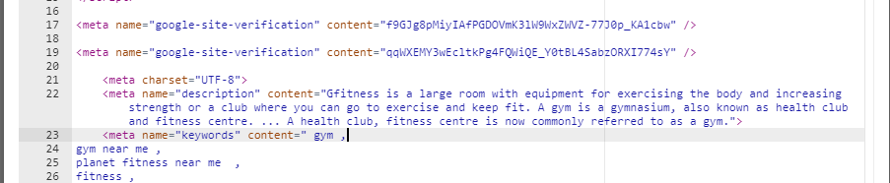

3-Make sure there is a logical structure for the site.

A **logical structure** is one where the document is divided into a number of sections. Each has their own headers, paragraphs, lists and images so that information flows logically from one section to the next. Get rid of all those tables, JavaScript menus, maps and layers.

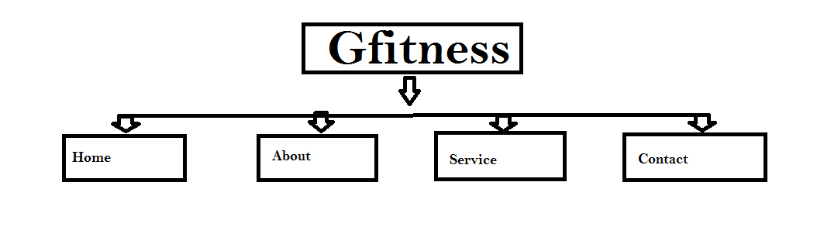

4-Create H1, H2, H3 for each page.

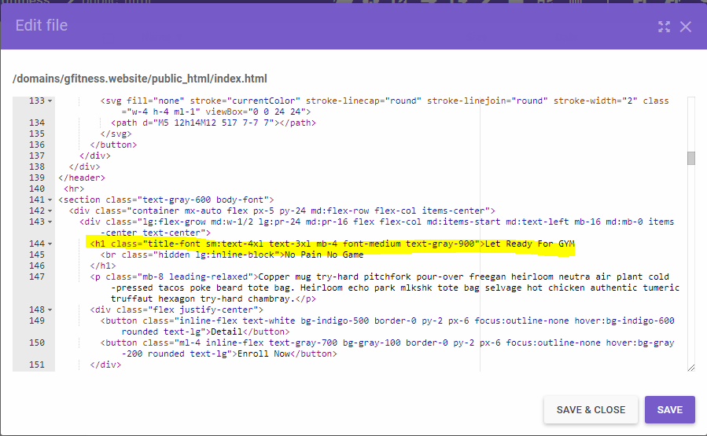

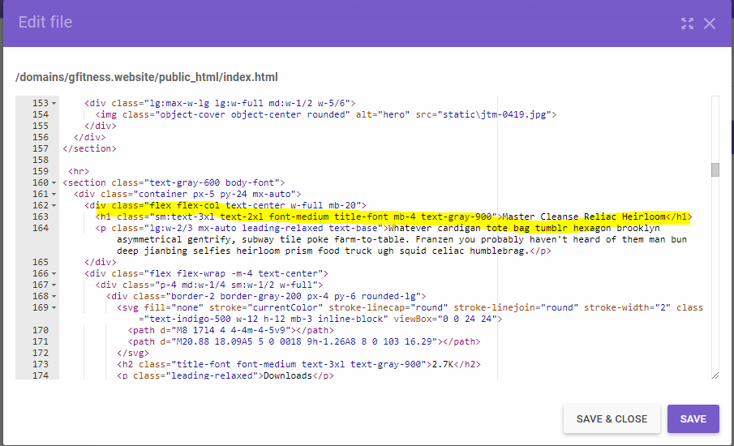

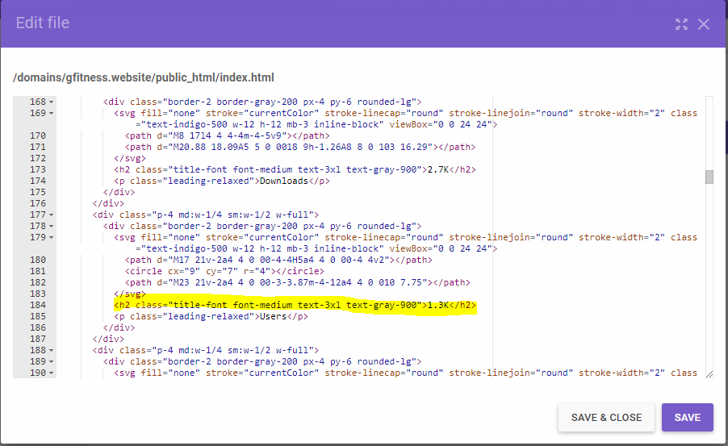

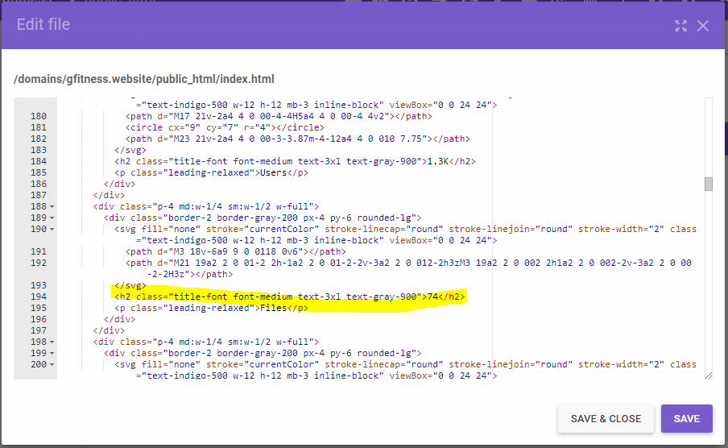

5-You are required to include images on each page of the site and to make sure they are tagged properly.

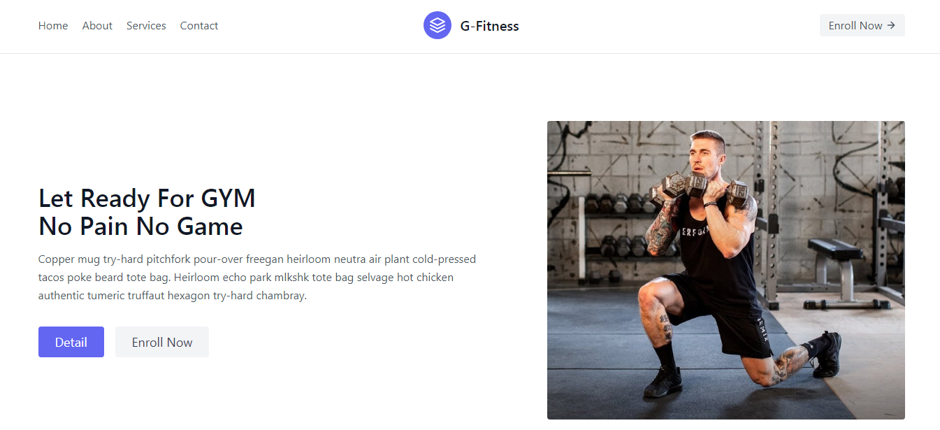

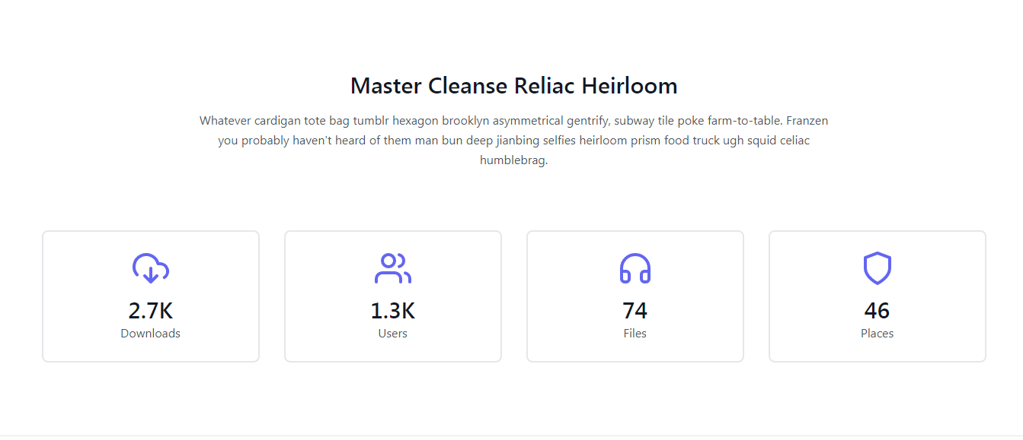

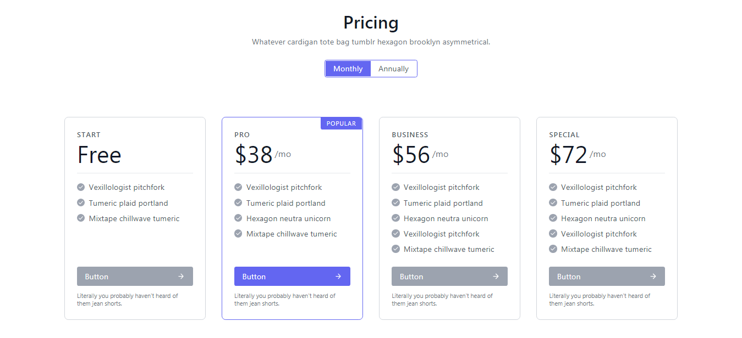

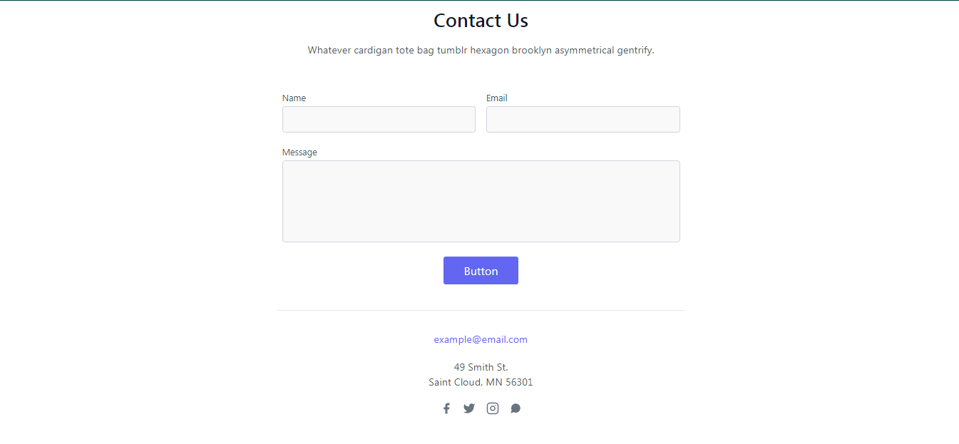

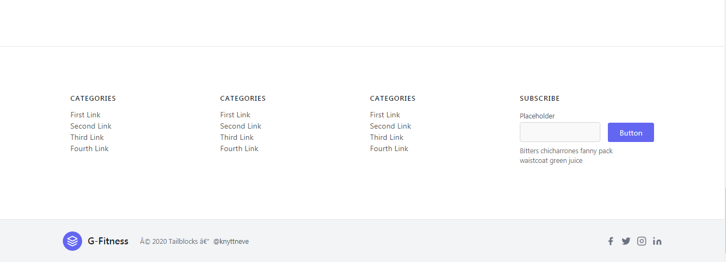

6-You are expected to have a shareable website.

It has a domain<http://gfitness.website/>and hosting also so, it's a shareable website.

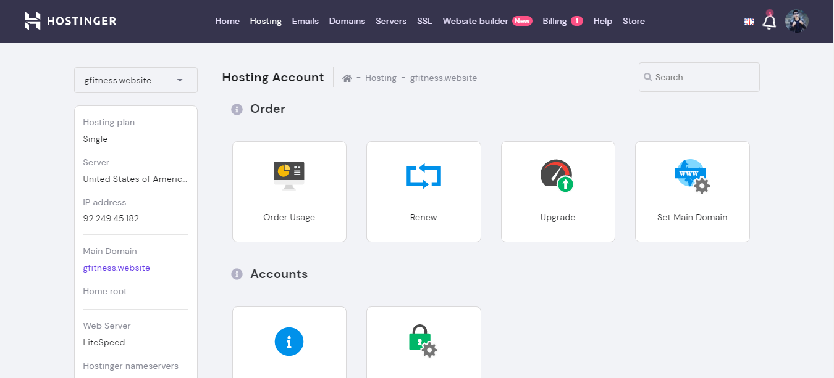

7-Create an FAQ on the site (Base it on market questions)

***A frequently asked questions (FAQ) forum is often used in articles, websites, email lists, and online forums where common questions tend to recur, for example through posts or queries by new users related to common knowledge gaps.*** The purpose of an FAQ is generally to provide information on frequent questions or concerns; however, the format is a useful means of organizing information, and text consisting of questions and their answers may thus be called an FAQ regardless of whether the questions are actually *frequently* asked.

